6.3 Test Execution
Test 1 – Incident Creation
Action: Create an incident with the required ticket details.
Expected Result:
The incident should be created successfully.
Screenshot
+-----------------------------------------------------------------------------------------+
| ServiceNow | Incident > Create New |
+----------------------------------------------------------------------------------------+
| |
| * Incident Number: INC0010001 |
| * Caller: Abel Tuter |
| * Category: Software |
| * Subcategory: Email |
| * Short Description: User unable to access Microsoft Outlook email service |
| * State: New |
| |
| [ Submit] [ Save] |
+-----------------------------------------------------------------------------------------+
Caption:
Figure 1: Incident Creation Test

Test 2 – Flow Trigger
Action: Create/update the incident according to the configured trigger condition.
Expected Result:
The Flow Designer flow should be triggered Screenshot:
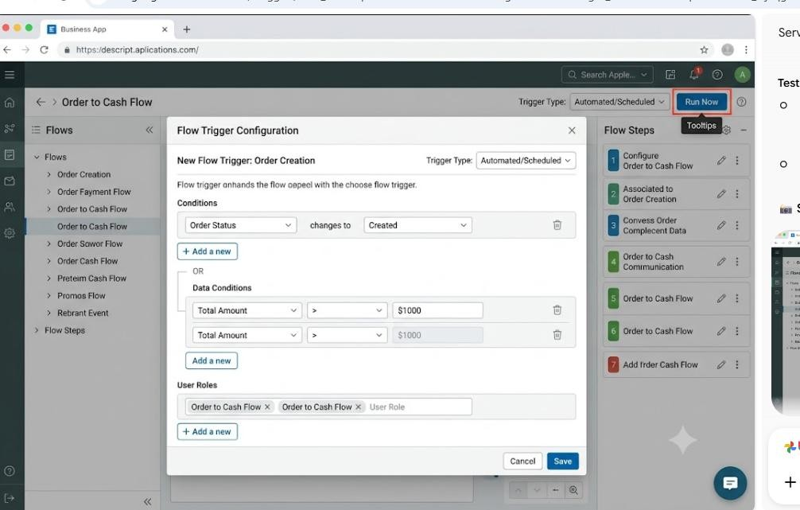
Caption:
Figure 2: Flow Trigger Test

Test 3 – Ticket Classification
Action: Provide ticket information that matches the configured classification condition.
Expected Result:
The ticket should be classified according to the configured condition
Screenshot:
+-----------------------------------------------------------------------------------------+
| ServiceNow | Incident > INC0010001 |
+----------------------------------------------------------------------------------------+
| |
| Incident Number: INC0010001 |
| Short Description: Unable to connect to corporate VPN network
|
| |
| [ Classification Logic Matched] |
| * Category: Network <-- (Auto Classified) |
| * Subcategory: VPN <-- (Auto Classified) |
| * Priority : High |
| |
+-----------------------------------------------------------------------------------------+.
Caption:
Figure 3: Ticket Classification Test

Test 4 – Assignment Group
Action: Check the assignment group after flow execution.
Expected Result:
The ticket should be assigned to the appropriate assignment group.
Screenshot:
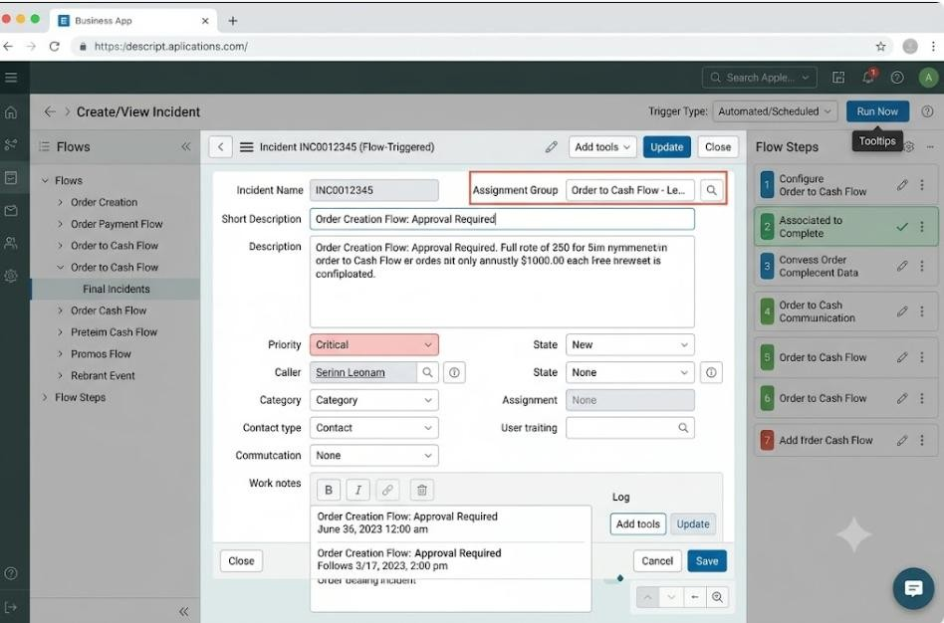
Caption:
Figure 4: Assignment Group Test

